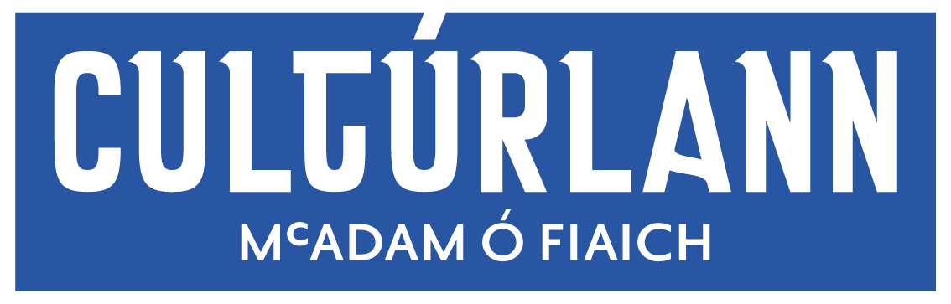

Exhibition Policy
This policy is intended to give guidance concerning the programming policy within An Cultúrlann’s galleries.
Our Mission
- To curate a quality programme of yearly exhibitions that resonate with our community, while also challenging our audience to encounter new experiences through art.
- To provide high quality visual arts experiences for our community and our children and young people through Irish.
- To build meaningful visual arts engagement experiences through Irish that draw on international best practice.
- To foster a culture that celebrates, supports, and respects visual artists and their work.
Programming
Our exhibitions are curated through a yearly open submission process managed by a visual arts assistant and curated by a committed visual arts panel. We currently have 4 well established members on our visual arts panel, Emma Berkery, Andrew Whitson, Aisling O’Beirn and Sean Mackel.
Both galleries showcase a variety of carefully curated professional artist’s work through the open submission process, while maintaining our community links and support for young artists, through our annual partnership with Colaiste Feirste and annual Gerard Dillion Graduate Award for UU Fine Art graduates.
In the event that the number of exhibition slots available, exceeds the number of successful applications, the panel reserve the right to curate the remaining slots as they see fit.
Dánlann Dillon & Ballaí Bána
We have two art galleries within the building, the only dedicated public art galleries in West Belfast. The Dillon Gallery, a beautiful, large, ground floor space with a striking curved wall and The Ballaí Bana, a more intimate, upstairs gallery. Both spaces are recognised as art galleries and funded as such by our principal funder The Arts Council of Northern Ireland.
The Dillion Gallery is dedicated to established professional artists and the Ballaí Bana exhibiting the work of emerging professional artists. All exhibiting artists are paid in accordance with Visual Artist Ireland recommendations, and we offer extensive support to our artists in the coordination, marketing and installation of their exhibitions.
- Wall Based art only.
Unfortunately, An Chultúrlann cannot facilitate floor-based exhibitions through the open call. Programming the galleries is the responsibility of An Chultúrlann, our gallery space has a high footfall and number of events taking place in our building.
- All sales of work MUST be conducted through the gallery by An Chultúrlann staff for the duration of the exhibition with sold artwork remaining with the gallery to be collected by the purchasers. All work for sale must include the gallery commission of 30% in the sale price if you are exhibiting with us in the Dánlann Dillon and a gallery commission of 20% if you are exhibiting in the Ballaí Bána.
- Once granted an exhibition based upon your proposal, no changes can be made without prior agreement.
All artists will receive a contract outlining terms and conditions of their exhibition which will be delivered by our visual arts assistant.
N.B. The visual arts panel reviews all eligible applications and has full discretion over the content of shows. The panel supports freedom of expression, however submissions of artworks that are judged to be inciting hatred, violence or are of an overly sexualised nature will not be exhibited. All panel decisions are final.

Gallery Opening times:
Monday - Friday: 10:00 – 5pm
Saturday: 10:00 – 4pm
Sunday: Closed

